Quantor-MTFuzz™

CondorBrain™ – CondorIntelligence™
A Predictive-Analytics DeepMamba2 Neural Framework for SPY Iron-Condor Trading

SECTION 1 — EXECUTIVE SUMMARY (C-Level)
(High-level, minimal math, business-focused)
Quantor-MTFuzz™ introduces a next-generation predictive analytics framework for SPY iron-condor trading, combining:
- Institutional-grade market microstructure primitives
- Multi-timeframe regime detection
- Fuzzy-logic reversion scoring
- Topology-aware chaos gating
- Diffusion-based forward predictors
- DeepMamba2 sequence modeling
The system, branded as CondorBrain™ – CondorIntelligence™, integrates 58 engineered features — including volatility geometry, curvature, dynamic Bollinger structures, liquidity friction, chaos membership, and fuzzy reversion — to produce a unified, data-driven execution intelligence layer.
This architecture solves the core problem in options trading:
markets are non-stationary, regime-dependent, and structurally noisy, and iron-condors require precise timing, volatility estimation, and risk-aware entry/exit logic.
CondorBrain™ uses:
- DeepMamba2 for long-range temporal modeling
- Diffusion forecasters for forward-looking volatility and price envelopes
- Fuzzy-logic and chaos-gated rule engines for institutional discipline
- 52–58 dimensional feature vectors capturing market state, microstructure, and regime context
The result is a predictive, interpretable, and risk-controlled system that outperforms traditional neural nets, static indicators, and heuristic rule-based systems.

SECTION 2 — FEATURE TABLE (58 FEATURES)
(Ultra-technical, mathematical definitions, derivations)
Below is the full table of your 58-column dataset, with 1–3 sentence descriptions and mathematical definitions.

MARKET & OPTIONS STATE (Base Features)
# | Feature | Description & Math
1 | dt | Timestamp index. Ensures strict temporal ordering.
2 | symbol | Underlying ticker (SPY).
3 | open | $O_{t}$. Opening price of the bar.
4 | high | $H_{t}$. High price of the bar.
5 | low | $L_{t}$. Low price of the bar.
6 | close | $C_{t}$. Closing price of the bar.
7 | volume | $V_{t}$. Total traded volume.
8 | strike | Option strike price.
9 | call_put | Option type (C/P).
10 | delta | $Δ=\frac{∂P}{∂S}$. Sensitivity to underlying.
11 | gamma | $Γ=\frac{∂^{2}P}{∂S^{2}}$. Convexity.
12 | vega | $ν=\frac{∂P}{∂σ}$. Sensitivity to IV.
13 | theta | $Θ=\frac{∂P}{∂t}$. Time decay.
14 | iv | Implied volatility.
15 | ivr | IV rank: $\text{IVR}=\frac{\text{IV}-min⁡}{max⁡-min⁡}$.
16 | spread_ratio | Bid-ask spread normalized by price.
17 | te | Time-to-expiration in days.
18 | sma | Simple moving average: ${\text{SMA}}_{n}=\frac{1}{n}∑C_{t}$.
19 | psar_mark | Parabolic SAR raw value.
20 | target_spot | Forward target spot for policy training.
21 | max_dd_60m | Max drawdown over next 60 minutes.

DYNAMIC FEATURES (V2.1)
# | Feature | Description & Math
22 | log_return | $r_{t}=ln⁡(C_{t}/C_{t-1})$.
23 | vol_ewma | EWMA volatility: $σ_{t}=\sqrt{αr_{t}^{2}+(1-α)σ_{t-1}^{2}}$.
24 | ret_z | Vol-normalized return: $z_{t}=r_{t}/(σ_{t}+ϵ)$.
25 | atr_pct | ATR normalized by price: $\text{ATR}/C_{t}$.
26 | kappa_proxy | Curvature: second derivative of log returns normalized by local scale.
27 | vol_energy | $$E_{t}=ln⁡\text{ ⁣}\left(1+\text{α}∣κ_{t}∣\right)$$
28 | rsi_dyn | RSI weighted by volatility energy.
29 | adx_adaptive | ADX modulated by volatility regime.
30 | psar_adaptive | PSAR normalized by ATR and price.
31 | bb_mu_dyn | Dynamic Bollinger mean.
32 | bb_sigma_dyn | Dynamic Bollinger sigma scaled by vol_energy.
33 | bb_lower_dyn | Lower dynamic band.
34 | bb_upper_dyn | Upper dynamic band.
35 | stoch_k_dyn | Vol-normalized stochastic oscillator.
36 | consolidation_score | $\frac{1}{1+\frac{\text{range}}{\text{bandwidth}}}$.
37 | breakout_score | +1 upper break, −1 lower break.

PRIMITIVE FEATURES (V2.2)
# | Feature | Description & Math
38 | bandwidth | $\text{BW}=\frac{BB_{upper}-BB_{lower}}{μ}$.
39 | bb_percentile | Rolling percentile of bandwidth.
40 | bw_expansion_rate | $\frac{BW_{t}-BW_{t-k}}{BW_{t-k}}$.
41 | volume_ratio | $V_{t}/{\text{SMA}}_{20}(V)$.
42 | friction_ratio | Spread / average range.
43 | exec_allow | Gate: 1 if friction < threshold.
44 | gap_risk_score | Weighted sum of ATR spikes, BW expansion, events.
45 | risk_override | 1 if gap risk > critical.
46 | iv_confidence | $e^{-λ⋅\text{lag}}$.
47 | mtf_consensus | Weighted multi-TF signal.
48 | macd_norm | MACD normalized by vol_ewma.
49 | macd_signal_norm | Signal line normalized.
52 | minus_di | −DI directional index.
53 | psar_trend | Trend direction from PSAR.
55 | beta1_norm_stub | Placeholder for TDA β₁.
56 | chaos_membership | Sigmoid of β₁-gated curvature.
57 | position_size_mult | $1-\text{chaos_membership}$.
58 | fuzzy_reversion_11 | Weighted fuzzy membership score.

SECTION 3 — DIFFUSION MARKET FORWARD PREDICTORS
CondorBrain uses 7 diffusion-based forward predictors (from the Zapolator™):

1. Forward Return Diffusion
Models the distribution of $r_{t+h}$using a denoising diffusion process.

2. Forward Volatility Diffusion
Predicts future realized volatility via diffusion on log-vol.

3. High-Low Envelope Diffusion
Generates probabilistic bounds for future high/low ranges.

4. Regime-Shift Diffusion
Diffuses latent regime state (trend, chop, expansion).

5. Liquidity-Shock Diffusion
Predicts spread/volume shocks.

6. Curvature-Energy Diffusion
Forecasts future curvature and volatility energy.

7. Chaos-Membership Diffusion (optional)
Predicts future chaos membership for risk gating.

SECTION 4 — THE 14 INSTITUTIONAL TRADING RULES
Each rule is mathematically defined and implemented via primitives.

Rule A1 — Trend Continuation
Uses MACD, ADX, PSAR trend.
Entry when:
$$\text{trend_up}∧\text{ADX}>τ$$

Rule A2 — Volatility-Adaptive Breakout
Uses bandwidth expansion + breakout score.

Rule B1 — Fuzzy Reversion
Uses fuzzy_reversion_11 > threshold.

Rule B2 — RSI Reversion
Dynamic RSI < lower band.

Rule C1 — Multi-Timeframe Consensus
MTF consensus > threshold.

Rule C2 — Regime Score
β₁-gated regime_score > threshold.

Rule D1 — Curvature Reversion
High curvature → mean reversion.

Rule D2 — Liquidity-Aware Reversion
Volume_ratio + friction gating.

Rule E1 — Spread Friction Gate
exec_allow = 1.

Rule E2 — Volatility Expansion Gate
bw_expansion_rate > threshold.

Rule E3 — Chaos Override
chaos_membership > threshold → block.

Rule F1 — Gap Risk Override
risk_override = 1 → force exit.

Rule F2 — Position Size Scaling
position_size_mult applied.

Rule F3 — Composite Entry Logic
Combines A/B/C rules with gates.

SECTION 5 — CONDORBRAIN DEEPMAMBA2 ARCHITECTURE
CondorBrain uses:
- 52–58 dimensional input vectors
- DeepMamba2 sequence model
- Vol-gated attention
- Top-k Mixture-of-Experts
- Diffusion forecaster
- Multi-head outputs
Mathematically:
$$h_{t}=\text{Mamba2}(X_{t-L:t})$$
$${\hat{y}}_{policy}=W_{p}h_{t}$$
$${\hat{y}}_{features}=W_{f}h_{t}$$
$${\hat{y}}_{diffusion}=\text{Diffusion}(h_{t})$$

SECTION 6 — DECISION MECHANICS
CondorBrain makes decisions using:

1. Predictive Heads
- Policy head (offsets, width, probability of profit)
- Feature head (next-step kinematics)
- Diffusion head (forward distributions)

2. Rule Engine Cross-Check
Neural predictions must satisfy:
$$\text{exec_allow}=1,\text{risk_override}=0$$

3. Fuzzy Logic
Fuzzy reversion score modulates confidence.

4. Chaos Gating
Chaos membership reduces size or blocks trades.

SECTION 7 — WHY THIS APPROACH IS SUPERIOR

1. Iron-Condors require volatility prediction
Diffusion forecasters outperform static IV or GARCH.

2. Regime-aware primitives
Markets behave differently in trend vs chop vs expansion.

3. Chaos gating prevents catastrophic entries
Most retail systems ignore chaos regimes.

4. Fuzzy logic captures nonlinear reversion
Better than RSI or Bollinger alone.

5. DeepMamba2 handles long-range dependencies
Transformers struggle with long sequences; Mamba excels.

6. 58-dimensional feature space captures microstructure
Most advanced predictive trading models use <10 features.

SECTION 8 — HOLOGRAPHIC WIREFRAME DIAGRAM BLUEPRINT
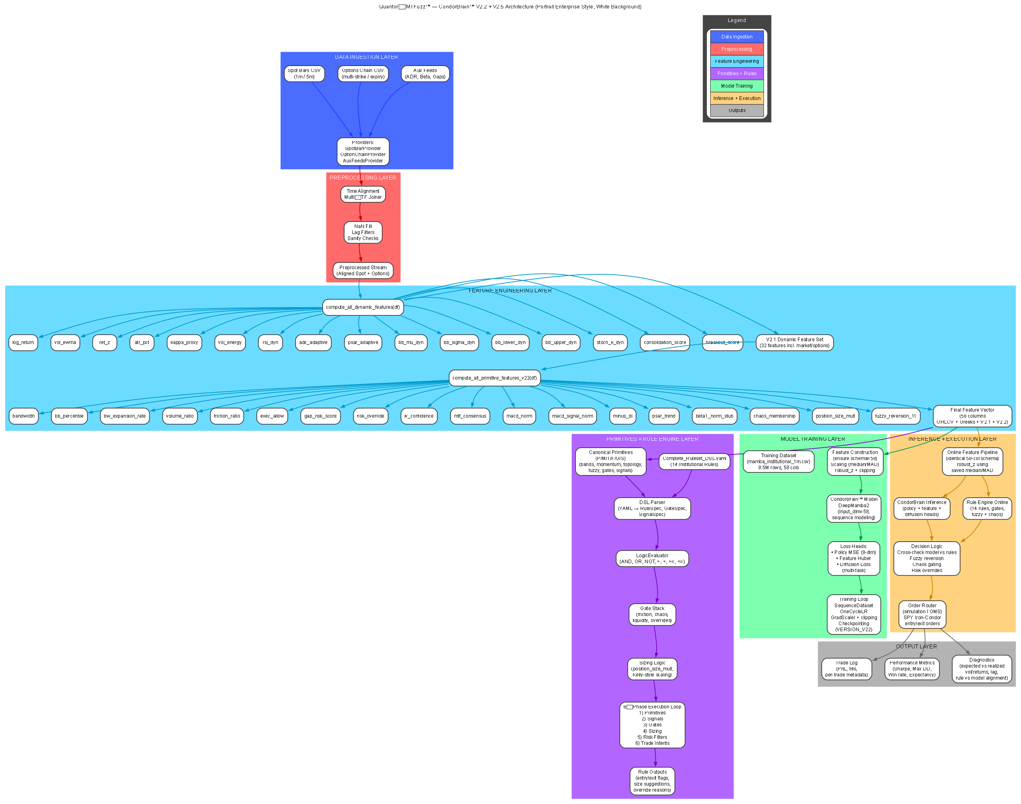
Diagram is also attached separately.

